Study Guide

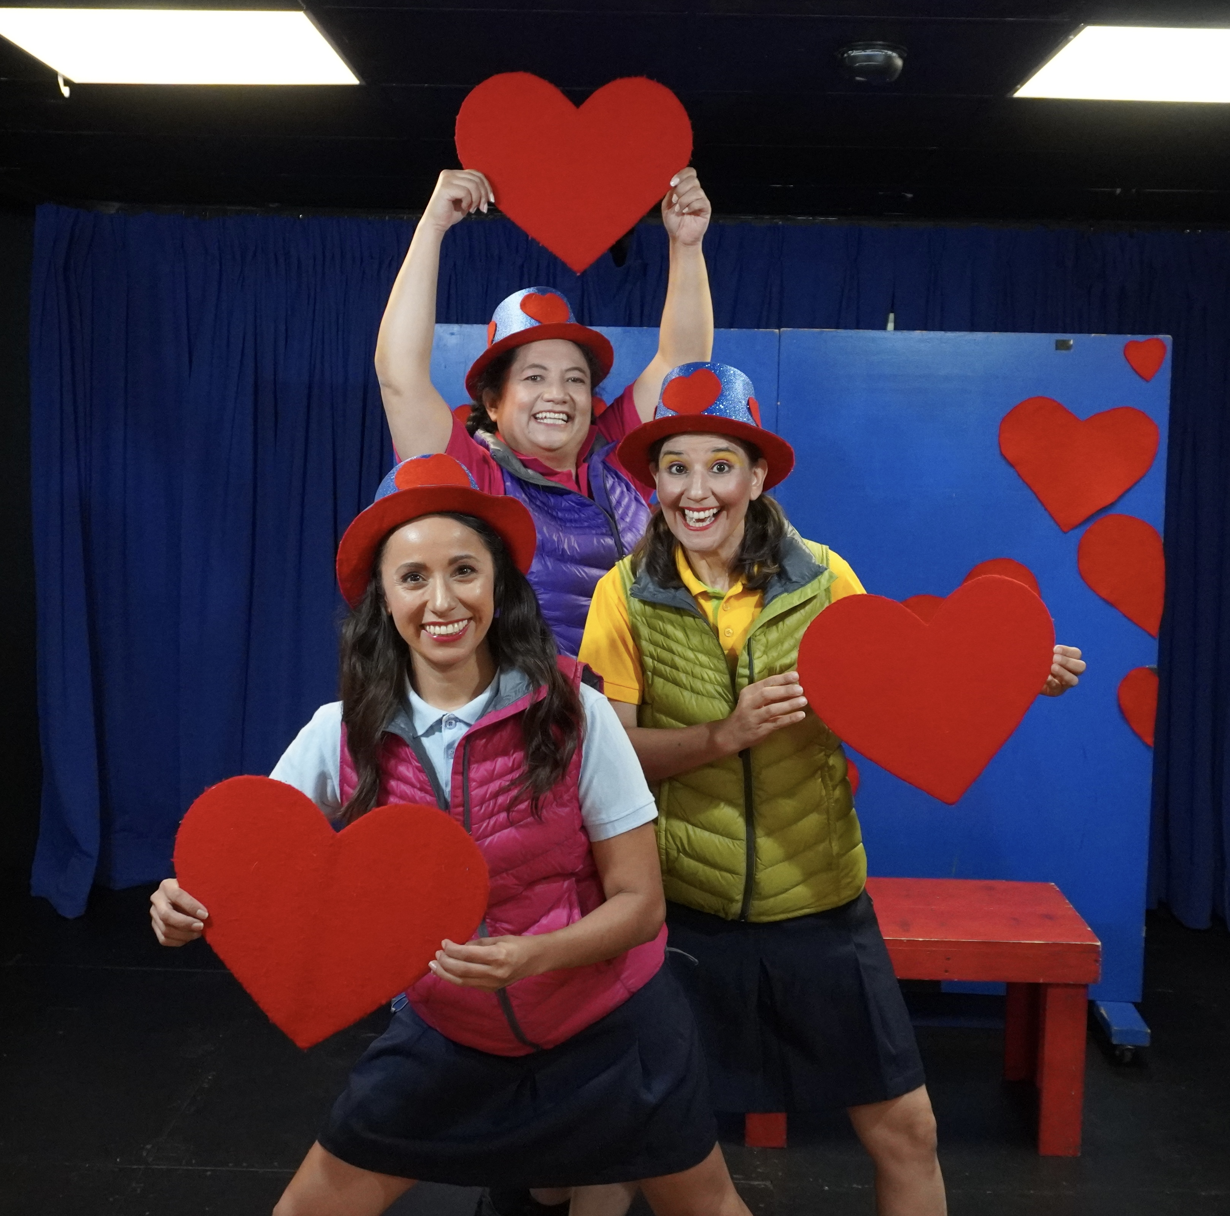

“Siempre Amigos”
(Buddies, not Bullies)

by Neher Jacqueline Briceño

Table of Contents

Summary of the Play ……………………………………………………3
Spanish Vocabularies and Translations ………………...…………….…4
Spanish Phrases with English Translations ……………………....…..…5
Helpful Websites………………………………………………….……..5
Theater Vocabulary in Spanish and English ..………………………..…6
Performance Related Classroom Activities
1) Pre K through 1st Grade ……………………………………….……7
2) 2nd Grade through 4th Grade ……………………….…………….....7
3) 5th Grade …………………….………………………………………7
Biography of Playwright and Director Jacqueline Briceño …….………8
Bibliography ……………………………………………………………9

Summary of the Play
Through comedy and clowning, this play shows the harsh realities behind this ever-so-present issue. While exposing the “cons” of bullying, it reinforces all the “pros” of being buddies.
Three actresses become different characters to narrate the story of Lolita, the girl whom with the help of her friends, the Blue Bird and Mrs. Parrott, over-came bullying. This play underlines the cons of bullying and the pros of being buddies.

Spanish Vocabulary with English Translation
by Grade Level

Pre-K through 1st Grade

Alegría: happiness
Tortuguita: little turtle
Bonita: pretty

2nd through 4th Grade

Identificamos: identify ourselves
Sinceros: sincere
Populares: popular
Sinceros: sincere
Populares: popular
Desaparecer: disappear
Humillación: humiliation
Causar: cause
Tener: have
Poder: power

5th Grade

Identificamos: identify ourselves
Sinceros: sincere
Populares: popular
Desaparecer: disappear
Humillación: humiliation
Temor: fear
Causar: cause
Tener: have
Poder: power

Spanish Phrases with English Translation
“Defiende tu razón”: Defend yourself
“No me atrevo a decir nada”: I don’t dare say anything
“Tienes que empezar por creer en tí misma.”: You have to start by believing in yourself.
“Muéstrenme sus corazones.”: Show me your hearts.
“Me tiemblan las manos…están sudadas y frías como si me fuera a desmayar…”: My hands are trembling…they are cold and sweaty, as if I were to faint…”
“Mi cuello se me arruga.” : My neck wrinkles up.
“La mano derecha da”: The right hand gives
“La mano izquierda recibe”: The left hand receives
“Mostramos nuestra Amistad”: We show our friendship
“Y el corazón sonríe.”: And the heart smiles.
“No mientan.” : “Don’t lie.”
“Me ofenden.” : You offend me.
“No permitiré que vuelvan a ofenderme ni a maltratarme”: I won’t allow you to offend me or mistreat me anymore.
“Soy tan fuerte como ustedes y mi corazón es tan noble y bueno, que de ahora en adelante no volverá a temer”: I am as strong as you and my heart is so noble and kind, that from now on, it will no longer fear.”
“Y la próxima vez que se atrevan a hacer sentir mal a un niño de la escuela…la próxima vez que hagan sentir triste el corazón de cualquier niño…Yo misma me encargaré de defenderlo y de hablar con un adulto de esta escuela para que les ponga en su lugar a ustedes dos!” :
“And the next time that you all make any kid of this school feel bad…the next time you make anyone’s heart sad…I will defend him or her and will speak to an adult of this school and make sure you two learn your lesson.”
“Gracias Lolita! Gracias por habernos enseñado a ser realmente amigas y a darnos cuenta lo mal que nos comportábamos.”: Thanks Lolita! Thanks for teaching us to be true friends and pointing out our bad behavior.”
“Lo logré…Pensé que no podía.” : I accomplished it..I thought I would not be able to.

HELPFUL WEBSITES
http://www.stopbullying.gov/what-is-bullying/
http://www.stopbullying.gov/respond/be-more-than-a-bystander
http://en.wikipedia.org/wiki/Bullying
http://www.thebullyproject.com/
https://www.google.com/search?q=bullying&biw=1264&bih=868&tbm=isch&tbo=u&source=univ&sa=X&ei=B9cNVOfSD7jGsQSquoGgBg&ved=0CGgQsAQ

Vocabulario de Teatro (Theater Vocabulary)

Autor (auw-TORE) Playwright: The person who wrote the play.
Actor/Actriz Actor/Actress: The men and women who play the parts onstage.
(ahk-TORE/ahk-TREESTH)
Director (dee-reck-TORE) Director: The person who picks the actors and tells them what to do.
Escena/Escenario/ Scene/Stage/Scenery: All words related to the stage. The scene is the
Escenografía location where each part of a play takes place; the stage is the place
(ai-SAIN-ah, where the actors work, and the scenery is what they act in front of.
ai-sain-ARE-ee-oh,
ai-sain-oh-grah-FEE-ah)
Fotografía Photography. Photos have to be taken of all shows – for publicity, for
(foe-tow-grah-FEE-ah) program covers, and for reminders.
Maquillaje (mah-key-YA-hay) Makeup: All actors, both women and men, wear stage makeup to make them more visible from the audience.
Musicalización Music Design: Selecting what music is used for the play.
(moo-see-cah-lee-tha-see-OWN)
Producción Production: The people who organize everything about the play,
(pro-duke-see-OWN) including who will direct it, who will design and build the set, and where the costumes come from.
Sonido (sow-NEE-doe) Sound: Not just music is used during a play; many times there are other sounds involved, too.
Vestuario (ves-too-ARE-ee-oh) Costumes: What the actors wear to make them look different.
Utilería (oo-teel-air-EE-ah) Properties: everything that an actor uses onstage (such as the Old Woman’s embroidery).

Classroom Activities
These are not divided by grade level, as they work with every grade

Language Arts: Working as a class, play “Bad Words/Good Words”. Students volunteer all the “bad” words they can think of related to bullying (i.e., “lazy”, “fat”, “mean” etc.). The teacher writes the words on the board with a space next to them. Next the teacher asks students to give good words that would work in place of each mean word. Note that these are not necessarily opposite words (because “skinny” can be as mean a word as “fat” is). Instead of “lazy”, a student might suggest “relaxed”; instead of “ugly” try “interesting”. With younger students the teacher may have to stimulate their imaginations at first, but the words will soon start coming quickly.

Art/Language Arts: Design and make a poster to fight bullying. Students can work either in groups (promoting cooperation) or individually. Younger students will need help with words and spelling, which the teacher might write on the board.
Physical Education/Cultural and Foreign Studies: Create a class dance having students suggest moves that come from their own cultures and ethnicities. This requires strong supervision, but the end result will be extremely rewarding and enlightening to students and teachers alike. Pick a simple song with a strong beat and positive message (or even better, wordless music). By having each student teach their move to the rest, each student is empowered and the other students learn respect and appreciation.
Critical Thinking/Language Arts/Cooperation: What is the difference between practical jokes and bullying? Working as a class, have students define each one. Are they the same thing always? After definitions are determined, have students work in groups and write/create a short play revolving around a non-bullying practical joke.

Pre-k-1st grades:
Draw and cut out large hearts and put the names of all your friends on the hearts.
With colored paper, draw and cut out hearts and decorate them.

2-3rd grades:
Make posters showing the best qualities your friends have; such as: are they kind? Helpful?
Write a song about friendship and perform it in front of your family and peers.
Make an anti-bullying poster.
On a large poster-size board write : “Siempre Amigos” and hang it in the classroom.

4th-5th grades:
Make anti-bullying posters to place around your school and community.
What are the “pros” of having good friends?
What are the “cons” of bullying?
Make a list of all the places where bullying can exist and find a solution so that it doesn’t have to exist.

Biography: Neher Jacqueline Briceño


Ms. Briceño was born and grew up in Venezuela. She began acting in 1973, when she joined the University Theater children’s theater group at the University of Carabobo in Venezuela. After several years, she became more interested in other parts of theater. She learned about producing, directing, working with music, playwriting and working with children. Finally, she took over the direction of the Academy of Children’s Theater for more than twelve years!

During that time, Ms. Briceño took part in more than 40 shows that included classical theater, Spanish theater and children’s theater. She won many awards for her work.
In 1997, Ms. Briceño moved to Miami, Florida. She started the Miami Children’s Theatre. The Miami Children’s Theatre was invited to bring a show to Teatro de la Luna’s International Festival of Hispanic Theater, where she first met the people from Teatro de la Luna. Since then, she has come back to create four shows for Teatro de la Luna’s Experience Theater Program. Besides Siempre Amigos (Buddies, Not Bullies), Ms. Briceño also wrote and directed Sanitos y Contentos (Happy and Healthy), Gotas de Agua (Drops of Water), El Gato y la Gaviota (The Cat and the Seagull), ABE: un sueño cumplido (ABE: a Dream Fulfilled), Hansel y Gretel (Hansel and Gretel), La Bella Durmiente (The Sleeping Beauty) and Las Aventuras de Pinocho (The Adventures of Pinocchio).
Ms. Briceño also won an important international award in Spain for an adult play she wrote.

Jacqueline Briceño still lives in Miami. She has a young boy now, who is learning in both English and Spanish.
Bibliography
Not in Our School
http://www.niot.org/nios?gclid=CKOSjNCek8ECFQMT7AodWRUAEA
StopBullying.Gov
http://www.stopbullying.gov/index.html

Mean Stinks
http://meanstinks.com/?utm_source=google&utm_medium=cpc&utm_term=%2Bstop%20%2Bbullying&utm_campaign=Secret.MeanStinks_Search_Lifestyle.BMM&utm_content=sKyZDOd2C_dc|54983923272

National Endowment for the Arts
http://www.nea.org/tools/lessons/teaching-students-to-prevent-bullying.html

