Study Guide
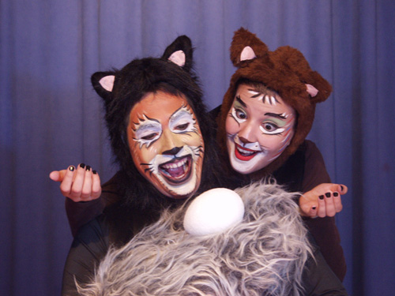
El Gato y la Gaviota
(The Cat and the Seagull)

by Jacqueline Briceño

Table of Contents
Synopsis of Story ………………………………………………………….…………… 3

Spanish Vocabulary, Translations & Pronunciation Guide ………………….………… 4

Theater Vocabulary in Spanish and English …………………………………………… 6

Spanish and English Sayings ...………………………………………………………… 6

English Vocabulary …..………………………………………………………………… 7

Pollution in the Ocean ………………………………………………………………….. 8

Seagulls ………………………………………………………………………………… 11

Biography of Luis Sepúlveda ……………………………………………………………12

Biography of Playwright Jacqueline Briceño ………………………………………….. 13

What Can I Do to Fight Pollution? …………………………………………………….. 14

Performance-Related Classroom Activities:
- Pre-K through 1st Grade ………………………………………………… 15
- 2nd through 4th Grade ………………………………………………..…. 15
- 5th through 8th Grade …………………………………………………… 16

Seagull Line Art ……………………………………………………………………….. 17

Map of the United States of America ………………………………………………….. 18

Map of South America ………………………………………………………………… 19

Summary of the Play

A beautiful, silver seagull was caught in an oil spill one day. Although she tried to fly away, she could only fly as far as an apartment balcony where Zorbas, a handsome, fat black cat was lying.

Zorbas was a very good cat. He was very concerned that the seagull was dying because of the oil. The seagull gained enough strength to lay her last egg, and asked Zorbas to promise three things:
- not to eat the egg,
- to care for the egg until it hatched,
- and to teach the baby seagull how to fly.
Although Zorbas was worried about how he, a cat, would teach a bird to fly, he promised. The mother seagull died.

Zorbas and his two cat friends, Colonnello and Sabelotodo, guarded the egg until it hatched. The baby bird was a girl, and Zorbas decided to name it Afortunada. The three cats took very good care of Afortunada and she grew into a beautiful seagull like her mother had been.

Now the cats had to teach Afortunada how to fly. After many tries, they finally found the right way and Afortunada flew off across the ocean.

This play is based on the book Historia de una gaviota y del gato que le enseño a volar (The Story of a Seagull and the Cat who Taught her to Fly) by Chilean Louis Sepúlveda.

Spanish Vocabulary with English Translations
by Grade Level

Pre-K through 1st Grade

aire (I-ray) …………………… air
alas (AH-lass) ………….…….. wings
alegre (ah-LAY-gray) ….…….. happy
amarillo (ah-mah-REE-yo) …… yellow
aquí (ah-KEY) ……………….. here
boca (BO-ka) ………………… mouth
bola (BOW-la) …………….…. ball
cara (CAR-rah) ………………. face
comer (ko-MARE) …………… to eat
cuerpo (coo-AIR-poh) ……….. body
donde (DOUGHN-day) ………... where
dormir (door-MEER) ………... to sleep
enferma (ain-FAIR-mah) ……. sick
flaco (FLAH-ko) …….………... skinny
feliz (fay-LEEZTH) …………. happy
frío (FREE-oh) ……………….. cold
fuerte (foo-AIR-tay) …………. strong
gato (GAH-toe) …………….… cat
gaviota (gah-vee-OH-tah) ……. seagull
gordo (GORE-dough) ………… fat
gris (grease) …………………... gray
hambre (AHM-bray) …………. hunger
hermano (air-MAH-no) ….…… brother
hermosa (air-MOE-sah) ……… beautiful
hija (EE-ha) …………………... daughter
huevo (oo-AI-voh) …………… egg
juego (hoo-AI-go) ……………. game
luna (LOO-nah) ………………. moon
lluvia (YOU-vee-ah) …………. rain
madre (MAH-dray) …………... mother
manzana (mahn-ZTHA-nah) … apple
mar (MAR) …………………… ocean/sea
miedo (me-AID-oh) ………….. fear
mono (MOH-no) ……………… monkey
negro (NAY-grow) …………… black
norte (NOR-tay) ……………… north
nosotros (no-SO-trows) ……….. we
pelo (PAY-lo) ………………… hair
peor (pay-OR) ………………… worse
pequeño (pay-KAY-neo)………. little
plata (PLAH-tah) …………….. silver
playa (PLY-ya) ………………. beach
pluma (PLOO-mah) …………. feather
promesa (pro-MAY-sah) …….. promise
rabo (RAH-bo) ……………….. tail
sol (SOUL) …………………… sun
sucia/o (SUE-see-ah/oh) ……… dirty
triste (TREE-stay) ……………. sad
vida (VEE-dah) ………………. life
viento (vee-N-tow) …………… wind

2nd through 4th Grade

afortunada (ah-for-too-NAH-dah) fortunate
arrojar (ah-row-HAR) ………… to throw
ayudar (ai-you-DAHR) ………. to help
basurero (bah-sue-RARE-oh) … trash dump
botella (bo-tay-ya) ……………. bottle
buscar (boos-CAR) …………… to look for
cansada (cahn-SAH-dah) ……... tired
cascarón (cahs-ca-RONE) ……. egg shell
celebrar (say-lay-BRAR) ……... to celebrate
claro (CLAR-row) …………….. clear
correr (core-RRARE) …………... to run
cuidar (coo-ee-DAR) …………. to take care of
cumplir (coom-PLEER) ………. to carry out
decir (day-SEER) ……………… to say
dolor (dough-LORE) ………….. pain
elegante (el-ai-GAHN-tay) ……. elegant
enciclopedia (ain-see-clo-PAY-dee-ah)
………. encyclopedia
enseñar (n-say-NIAR) ………… to teach
escuchar (es-coo-CHAR) ……… to listen
frágil (FRAH-hill) …………….. fragile
iglesia (ee-GLAY-see-ah) …….. church
italiano (ee-tah-lee-AH-no) …… Italian
junto (HOON-toe) ……………. together
lágrimas (LAH-gree-mahs) …… tears (cry)
llamar (ya-MAR) …………..… to call/name
mancha (MAHN-cha) ………... stain
maullido (mau-YEE-dough) .... meow
morir (more-REAR) ………….. to die
mosca (MOHS-kah) …………. fly
nacer (nah-SARE) …………….. to be born
orgullo (or-GOO-yo) …………. pride
pegar (pay-GAR) ……………... to stick
peligro (pay-LEE-grow) ……… danger
perder (pair-DARE) …………… to lose
piloto (pea-LOW-toe) ……… pilot
plástica (PLAS-tea-ka) ……… plastic
polvo (POLL-vo) …………… powder
preguntar (pray-goon-TAR) … to ask
principio (preen-SEE-pea-oh) beginning
qualquier(a) (qual-key-AIR/ah) any
robar (row-BAR) …………... to steal
sabelotodo (sah-bay-low-TOW-dough)
………. know-it-all
salvo (SAL-voh) ……………. safe
sentir (sane-TIER) ………….. to feel
vacío (vah-SEE-oh) ………… empty
volar (voe-LAR) ……………. to fly

5th through 8th Grade

aconsejar (ah-cohn-say-HAR) .. to counsel
acostumbrar (ah-cohs-tomb-BRAR)
……… get used to
afirmar (ah-FEAR-mar) ……… to affirm
alcanzar (al-cahn-THAR) …….. to catch up with
apreciar (ah-pray-see-ARE) ….. to appreciate
arenques (ah-RAIN-case) ……. herrings
aterrizaje (ah-tair-ee-ZTHAH-hay) landing
babor (bah-BORE) …………… port(side)
bigotes (bee-GOAT-tays) ……. whiskers
botar (bo-TAR) ………………. to throw away
calamares (cah-la-MAR-ace) … squid
callejero (cah-yay-HAIR-oh) … street person
camparnario (cahm-par-NAR-ee-oh)
……… belfry
comelón (comb-ai-LONE) …… comedian
comprobar (comb-pro-BAR) … to check
corriente (core-ee-EN-tay) …… current- of air
derretir (dair-ray-TIER) ……… to melt
despegue (dace-PAY-gay) …… take-off (flight)
detente (day-TAIN-tay) ………. wait
dispuesto (dees-pooACE-tow) disponed to
espesa (ace-PAY-sah) ……… thick
estribor (es-tree-BORE) ……. starboard
genio (HAY-nee-oh) ………. genius
hembras (AIM-bras) ………. females
inteligencia (een-tell-ee-HEN-c-ah)
……… intelligence
lamer (lah-MARE) ………… to lick
lata (LAH-tah) ……………... tin/can
machos (MAH-choss) ……… males
maldición (mal-dee-see-OWN) curse
manada (mah-nah-dah) …….. flock
nido (KNEE-dough) ……….. nest
pajarraco (pah-ha-RACK-ko) big ugly bird
peludo (pay-LOO-dough) …. hairy
perezosamente (pay-ray-ztho-sah-MAIN-
tay) …….. lazily
peste (PAYS-tay) …………. plague
petróleo (pay-TROW-lay-oh) oil
picar (pea-CAR) …………… to peck
protección (pro-teck-see-OWN) protection
puerto (poo-AIR-tow) …….. harbor
puños (POO-nios) …………. fists
quitar (key-TAR) ………….. to take away
sardinas (sar-DEAN-ahs) …. sardines
tonelada (tone-ai-lah-dah) …. ton
vaya (VAI-ya) ……………... go on!
zumbido (zthoom-BEE-dough) buzzing

Vocabulario de Teatro Theater Vocabulary

Autor (auw-TORE) Playwright: The person who wrote the play.
Actor/Actriz Actor/Actress: The men and women who play the parts onstage.
(ahk-TORE/ahk-TREESTH)
Director (dee-reck-TORE) Director: The person who picks the actors and tells them what to do.
Escena/Escenario/ Scene/Stage/Scenery: All words related to the stage. The scene is the
Escenografía location where each part of a play takes place; the stage is the place
(ai-SAIN-ah, where the actors work, and the scenery is what they act in front of.
ai-sain-ARE-ee-oh,
ai-sain-oh-grah-FEE-ah)
Fotografía Photography. Photos have to be taken of all shows – for publicity, for
(foe-tow-grah-FEE-ah) program covers, and for reminders.
Maquillaje (mah-key-YA-hay) Makeup: All actors, both women and men, wear stage makeup to make them more visible from the audience.
Musicalización Music Design: Selecting what music is used for the play.
(moo-see-cah-lee-tha-see-OWN)
Producción Production: The people who organize everything about the play,
(pro-duke-see-OWN) including who will direct it, who will design and build the set, and where the costumes come from.
Sonido (sow-NEE-doe) Sound: Not just music is used during a play; many times there are other sounds involved, too.
Vestuario (ves-too-ARE-ee-oh) Costumes: What the actors wear to make them look different.
Utilería (oo-teel-air-EE-ah) Properties: everything that an actor uses onstage (such as the Old Woman’s embroidery).

Spanish and English Sayings

Spanish
Quitar las palabras de la boca

bola de pelo

gato de puerto

ir al grano

todos para uno y uno para todos

English
Take the words out of one’s mouth.

fur-ball

harbor cat

come to the point

all for one and one for all

English Vocabulary & Definitions

Pre-K through 1st Grade
balcony: A platform that comes out of the wall of a house. (We grow plants on our balcony.)
chick: a baby bird. (A mother hen takes good care of her chicks.)
dirty: not clean. (The mother seagull got very dirty in the oil.)
friend: someone whom you know and like very much. (Zorbas is my best friend.)
hatch: when a baby bird or reptile comes out of its shell. (Zorbas watched Afortunada hatch.)
help: to be useful to someone else. (I help my mother with the dishes.)
hungry: needing food right away. (I’m always hungry for lunch.)
promise: something you say you will do and really mean it. (Zorbas promised to care for the baby seagull.)
something: a thing that isn’t named. (They looked for something to feed to Afortunada.)
trouble: to have a problem. (I’m in trouble because I broke the vase.)

2nd Grade through 4th Grade
adventure: an exciting and maybe dangerous experience. (It was an adventure to fly.)
beautiful: very pretty. (Afortunada was a beautiful silver seagull.)
carefully: taking care when you’re doing something. (He carefully picked up the egg.)
destroy: to put an end to; to make useless. (Pollution can destroy the ocean.)
discover: to find out. (Zorbas discovered the silver seagull on his balcony.)
feathers: the outer covering on birds. (Afortunada’s feathers were silver.)
final: last. (Labor Day is the final day the pool is open.)
human: a person. (What do humans eat?)
museum: a special building where valued objects are stored and shown. (The Smithsonian has museums for nature, airplanes, Native Americans and other things.)
pollution: putting harmful things into our water, air or land. (Pollution can make water unsafe to drink.)
port: a safe place where ships and boats can stay. (The port is filled with sailors.)
problem: something that must be worked out or solved. (Zorbas had a really problem teaching Afortunada to fly.)
stink: to give off a bad smell. (Dirty water can really stink.)
task: a piece of work that you must do. (Their task was to teach Afortunada to fly.)

5th Grade through 8th Grade
accomplish: to bring to a successful end. (Afortunada finally accomplished her first flight.)
beak: the bill of a bird. (The seagulls held fish in their beaks.)
contaminate: to make dirty or soiled. (The oil spill contaminated all the birds and fish.)
emergency: a serious situation that happens without warning. (When the emergency siren sounds, we all line up to leave the classroom.)
herrings: a small fish found in the North Atlantic; a valuable food source. (Herrings travel in huge schools.)
seagull: a type of bird that lives near coastlines. (Seagulls can be messy, noisy birds.)
surround: to enclose on all sides. (Afortunada was surrounded by love.)
suffer: to go through an unpleasant or painful experience. (Animals can suffer from pollution.)
victim: someone who is hurt or killed, either by accident, illness or intent. (The seagull mother was a victim of pollution.)
Pollution in the Ocean

The oceans of the world are becoming dirtier and dirtier. For years people thought that it did no harm to dump plastics, left-over rope, waste-water from ships, and even some oil into the ocean. They thought the ocean could clean itself easily. However, we know now that the ocean can only clean itself to a point.

Man-Made Products:
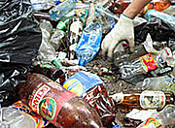
About 10% of the 100 million tons of plastics which are made each year end up in the ocean. 20% of this is thrown from ships, boats and platforms (like oil platforms); the rest comes from plastics left on land or in rivers and washed into the ocean. Most plastics do not disintegrate easily, so they’re with us for a long time. A single large soda bottle could break up into enough tiny pieces to be able to put one piece on every single mile of beach in the whole world.

Plastics can hurt and kill animals in the ocean. They eat the plastic thinking it is food.

Glass is also thrown away, but does not have as bad an impact on animal life as plastic does, mainly because it is heavier and sinks. However, broken glass has its own dangers.

Oil:
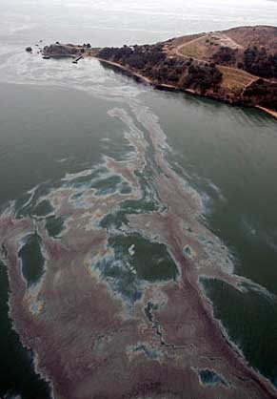
Most oil pollution does not come from big spills. It comes from people changing their car oil, regular cleaning of the inside bottoms of ships (bilges) and other ship activities, and air pollution from cars and factories that settles into the ocean through rain.

If one person changes his car oil and lets the old oil wash into the gutter instead of collecting and carefully getting rid of it, that oil can pollute a million gallons of water. Scientists estimate that about 363 million gallons of oil ends up in the ocean every year this way.

When sailors empty the bilges of ships, or clean the decks of ships, they wash about 137 million gallons of oil into the ocean by accident each year.

Air pollution causes about 92 million gallons of oil pollution each year when cars and factories pollute the air. The polluted air is condensed into clouds which rain into the ocean.
Only 5 percent of oil pollution is caused by big oil tanker accidents, though it still is about 37 million gallons of oil leaked into the ocean each year. Offshore drilling accounts for 15 million gallons of oil.
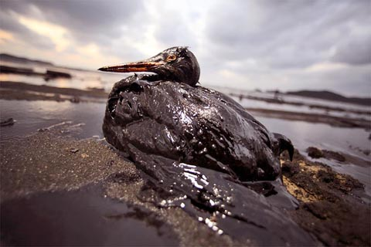
Some oil pollution is even natural, because there are places in the ocean where oil seeps through decaying rock into the water. This causes about 62 million gallons of oil pollution every year.

Animals and birds can be harmed for many years by oil pollution. The oil keeps birds from being able to fly. They also eat the oil by accident as they try to clean themselves. Every year over a million water birds die from oil pollution.

Gulf Oil Spill:

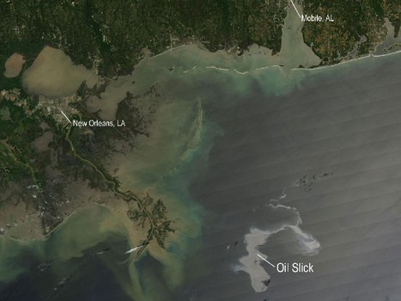
On April 20, 2010, there was a bad accident on an oil rig named the Deepwater Horizon in the Gulf of Mexico. The oil rig caught fire, burned up, and sank. Eleven men who worked on the rig died and 17 were hurt. Oil began to leak into the Gulf from the broken pipe of the oil rig. Scientists think the rate of oil coming into the Gulf is between 5000 barrels (about 210,000 gallons or 790,000 liters) and 100,000 barrels (4,200,000 gallons or 16,000,000 liters). This oil spill has caused a big oil slick on the water, currently covering about 2500 square miles, or 6500 square kilometers. Many people are calling this the worst oil disaster to ever take place. Many birds are dying. Fish, shrimp, and other sea life are also being killed by the oil. The coasts of Louisiana, Mississippi, Alabama and Florida have been affected and will take many years to get back to normal.

Algal Blooms:
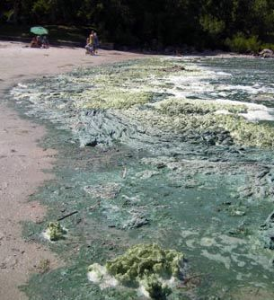
Water runoff from farms and cities is causing algae (very small plant-like things) to grow in rivers, bays and near coastlines around the world. Human and animal waste, plus fertilizers used in growing plants on farms, combines to form nutrients – mainly nitrogen and phosphorus. The amount of nitrogen and phosphorus in the water create algal blooms.

Algal blooms have always happened, but the number happening now is creating a problem. As the algae die, they take oxygen from the water. This causes fish to suffocate because they cannot breathe. Some kinds of algae can poison fish, birds and animals.
Seagulls

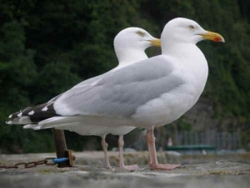
There are 11 main types of seagulls, but each of these types is also divided into sub-categories. Seagulls are usually grey or white; often with black marks on the head and wings. They are fairly large birds. The smallest, the Little Gull, is 11 ½ inches and weighs 4.2 ounces, while the biggest, the Great Black-Backed Gull, is almost 4 pounds and 30 inches long!

Seagulls have webbed feet and carefully oiled feathers, which let them float in the water rather than sinking. They have long, sharp beaks and very loud calls.

Seagulls nest on the ground in large, noisy groups. Their eggs are speckled, and they usually lay two or three at a time. The baby birds are dark speckled brown.

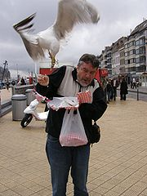
Highly intelligent animals, seagulls are also very curious and inventive. Some kinds of seagulls have even learned how to use tools.

In the wild, seagulls mainly eat fish. They dive into the water to fish. They also steal fish from other birds and from each other. Some will land on whales to steal the whale’s food. However, seagulls have learned to live with and near people. There are often seagulls that live near beaches and harbor towns. They look for food in trash cans and have been seen stealing food from people. They are very good at snatching food out of the air if it is thrown to them. Some gulls have even been seen trying to carry off family cats or small dogs. Seagulls are omnivores, meaning they eat both plants and animals.

Seagulls do not make good pets.

Biography: Luis Sepúlveda
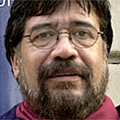
Born in Ovalle, Chile, in 1949, Luis Sepúlveda (pronounced say-POOL-vay-dah) didn’t begin as a writer. He thought he wanted to work in theater. He studied theater both in Chile and in Moscow, Russia.

In 1973 there was a military revolution in Chile. Mr. Sepúlveda was put in prison. He managed to escape, but was caught and given a life sentence.

Through the help of Amnesty International, he was allowed to go into exile. But Mr. Sepúlveda didn’t want to go to Sweden, where it had been arranged for him to teach. Instead, he escaped again and went from Argentina to Uruguay, Brazil and Paraguay. He ended up in Ecuador for awhile. He started a theater company, and then lived with Native Americans, where he helped start a reading program for them.

In 1979 he joined the fighting in Nicaragua. After the revolution was successful, he began writing for newspapers and magazines. In 1980 he moved to Europe for awhile, living in Germany.

He learned about Greenpeace in 1982, and decided to help it by working on one of its ships in 1987. He sailed all over the world with Greenpeace.

During all this time he wrote many books, both for adults and children, which have been translated into many different languages. He has also made some films.

Biography: Jacqueline Briceño

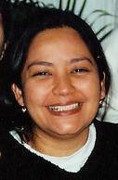
Ms. Briceño was born and grew up in Venezuela. She began acting in 1973, when she joined the University Theater children’s theater group at the University of Carabobo in Venezuela. After several years, she became more interested in other parts of theater. She learned about producing, directing, working with music, playwriting and working with children. Finally, she took over the direction of the Academy of Children’s Theater for more than twelve years!

During that time, Ms. Briceño took part in more than 40 shows that included classical theater, Spanish theater and children’s theater. She won many awards for her work.

In 1997, Ms. Briceño moved to Miami, Florida. She started the Miami Children’s Theatre. The Miami Children’s Theatre was invited to bring a show to Teatro de la Luna’s International Festival of Hispanic Theater, where she first met the people from Teatro de la Luna. Since then, she has come back to create four shows for Teatro de la Luna’s Experience Theater Program. Besides ABE: un sueño cumplido (ABE: a Dream Fulfilled), Ms. Briceño also wrote and directed Hansel y Gretel (Hansel and Gretel), La Bella Durmiente (The Sleeping Beauty) and Las Aventuras de Pinocho (The Adventures of Pinocchio).

Jacqueline Briceño still lives in Miami. She has a young boy now, who is learning in both English and Spanish.

What Can I Do to Help Fight Pollution?

1. Take shorter showers. Water used has to be treated, and that takes energy that causes pollution.

2. Use a broom instead of a hose to wash your front walk. This way you won’t waste water AND the dirt and other things on the walk won’t end up in the water system.

3. If possible, walk or bike to school instead of having your parents drive you. This saves gas and keeps car pollution from the air.

4. Turn off lights and the TV when you leave a room. This saves electricity.

5. If you have a leaky faucet or toilet, make sure your parents know about it. This way water won’t be wasted, plus your family will save money on the water bill.

6. If you can, plant a vegetable garden in your yard or in pots. Plants help protect the environment, plus you’ll be eating your own vegetables instead of those grown somewhere else.

7. Turn off the water when you brush your teeth and wash your hands and face.

8. If you can, plant bushes or a tree in your yard.

9. Encourage your parents to use recyclable bags when shopping. Plastic bags are made with oil and don’t decompose easily.

10. Together with some friends, adopt a park or part of your street. Keep it picked up and clean. This will keep trash out of the gutters and out of the water system.
Performance-Related Classroom Activities by Grade Level
Pre-K through 1st Grade:
Language/Spanish: There are several color words in the Spanish vocabulary list (noted in red on the list). Practice saying them with students, and have them match the colors with things in the classroom. What other color words do students know in Spanish?
Language/Spanish/Science: If your classroom regularly checks the weather, consider using some of the Spanish vocabulary words to describe that day’s weather (weather words in blue on the list). Do any of the children know any other weather words in Spanish?
Geography/Art/Spanish: The story takes place near a harbor. Discuss what a harbor is and draw an example on the board. Ask children to draw pictures of what they think a harbor looks like.
Science: Water pollution is a major aspect to the story. Bring in some pie-pans or similar shallow basins and partially fill with water. Add some drops of oil (any cooking oil will do). Ask students to try to blend the water and the oil; then ask what the results are. You might also ask students to dip some things into the oiled water and see the results (suggestions: paper, feathers, cloth).
Science/Art: On page 17 are line pictures of two seagulls and one chicken that can be reproduced for your classroom. As students are coloring the pictures, ask them what some of the differences are between seagulls and chickens. Can chickens fly? How are their feet different? Do we eat seagulls? What different sounds do they make?
English: Go over the English vocabulary words with your students. Ask children to use the words in sentences.
Art/Critical Thinking: Following the performance, ask students to draw a picture of Afortunada, Zorbas, Colonnello and Sabelotodo. Ask students to tell you their favorite character as they are drawing, and what part of the play they liked the best. Teatro de la Luna would love to see these pictures!

2nd through 4th Grades:
English/Spanish: There are several common sayings used in the play, listed on page 6 of this Study Guide. Every language has sayings that may not mean exactly what the words say. Go over the Spanish sayings with students, and then ask them what other common sayings they know in English (examples: “An apple a day keeps the doctor away,” “Don’t put all your eggs in one basket.”) or in Spanish.
English: In the play Sabelotodo carries around a big “enciclopedia” (the Spanish word). If you have an encyclopedia in your classroom or school library, ask students to look up words important to the play, including “pollution” and “seagull”. Ask students how using an encyclopedia is different from looking up things on a computer.
Geography/Spanish/Writing/Art: The play takes place near a port. What is a port? Ask students to look it up; then write about ports they may have seen. Included in the Spanish vocabulary are words highlighted in sea-green that might describe a port or items in it. Using the vocabulary, ask students to draw pictures of ports – both pretty, natural ports and ports that have been polluted.
Geography/Science: On page 18 is a map of the United States. Discuss the Gulf Oil Spill with your students and ask them to identify the states bordering the Gulf of Mexico. Which states are most affected by the oil spill?
Science/Art: On page 14 are line drawings of seagulls and a chicken. You can reproduce this page so each student has a copy. Ask students to color the images, while asking them about similarities and differences between seagulls and chickens.
Science/Art/Writing: Pollution is a key issue in the play. On page 8 of this Study Guide is a brief synopsis of issues involved in water pollution. Working in groups, assign students one of the major causes of water pollution and ask them to illustrate it however they want to (they might create a diorama, draw a picture, fill a large clear bottle with water and oil, etc.) and to present a short report on their findings.
Art: Using the template of the flying seagull, make multiple reproductions and ask students to cut out the images and glue them to cardboard. Then have them create mobiles of the flying seagulls with wire coat-hangers and strings, making sure the mobiles are balanced.
Art/Writing/Spanish/Cooperation: Following the performance, ask students to discuss their favorite parts of the play, using words from the Spanish and English vocabularies. Working together on a large sheet of paper, ask students to recreate their favorite scene through art. Teatro de la Luna would love to see this piece of art!
Literature/Critical Thinking: Read Jonathan Living Seagull to the children. Ask them the similarities between it and The Cat and the Seagull. What are the differences?

5th through 8th Grades:
Writing/Science: Individually or in groups ask students to prepare a one- or two-paragraph report on a specific type of seagull.
Spanish/Creative Writing: Using the Spanish Vocabularies on pages 4 and 5 of this Study Guide, ask students to write a short story, but substituting the Spanish words for English words in their stories. (i.e., a sentence might read, “When I was at the puerto the other day, a pajarraco flew down and stole some sardinas from a lata.”)
Science/Writing/Art: Working in groups, have students research the different causes of water pollution. Have them present their findings in as creative a way as they want – they might write a radio report, film a documentary, create a diorama, write their own story about pollution, etc.
Art: Ask students to design their own concept of a seagull costume for an actor. Would there be a mask, and, if so, what would it look like? If they prefer, ask some to design a costume for a cat.
Geography: Ask students to research a famous harbor and report on it. What natural shape does it have? Is it deep enough for large ships?
Geography: Using the map of South America on page 19, have students follow Luis Sepúlveda’s travels from his native Chile.
Writing/Critical Thinking: Following the performance, ask students to write their own review of the show, including which parts they like best, what needs work, etc. Discuss the set, costumes and direction with the class and ask them to assign points to all aspects. Teatro de la Luna would love to see these reviews!

Line Art for Classroom Projects

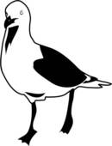
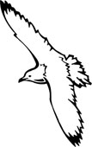

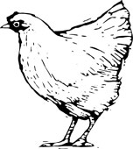

Map of the United States

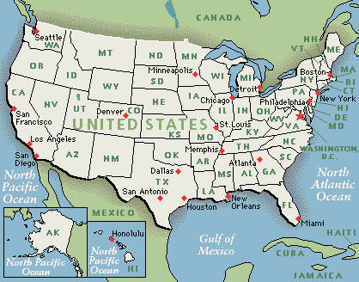

Map of South America
