“La Magia del Arcoíris”
The Rainbow’s Magic
Escrita y dirigida por/Written and directed by: Neher Jacqueline Briceño
Guía de Estudio / Study Guide
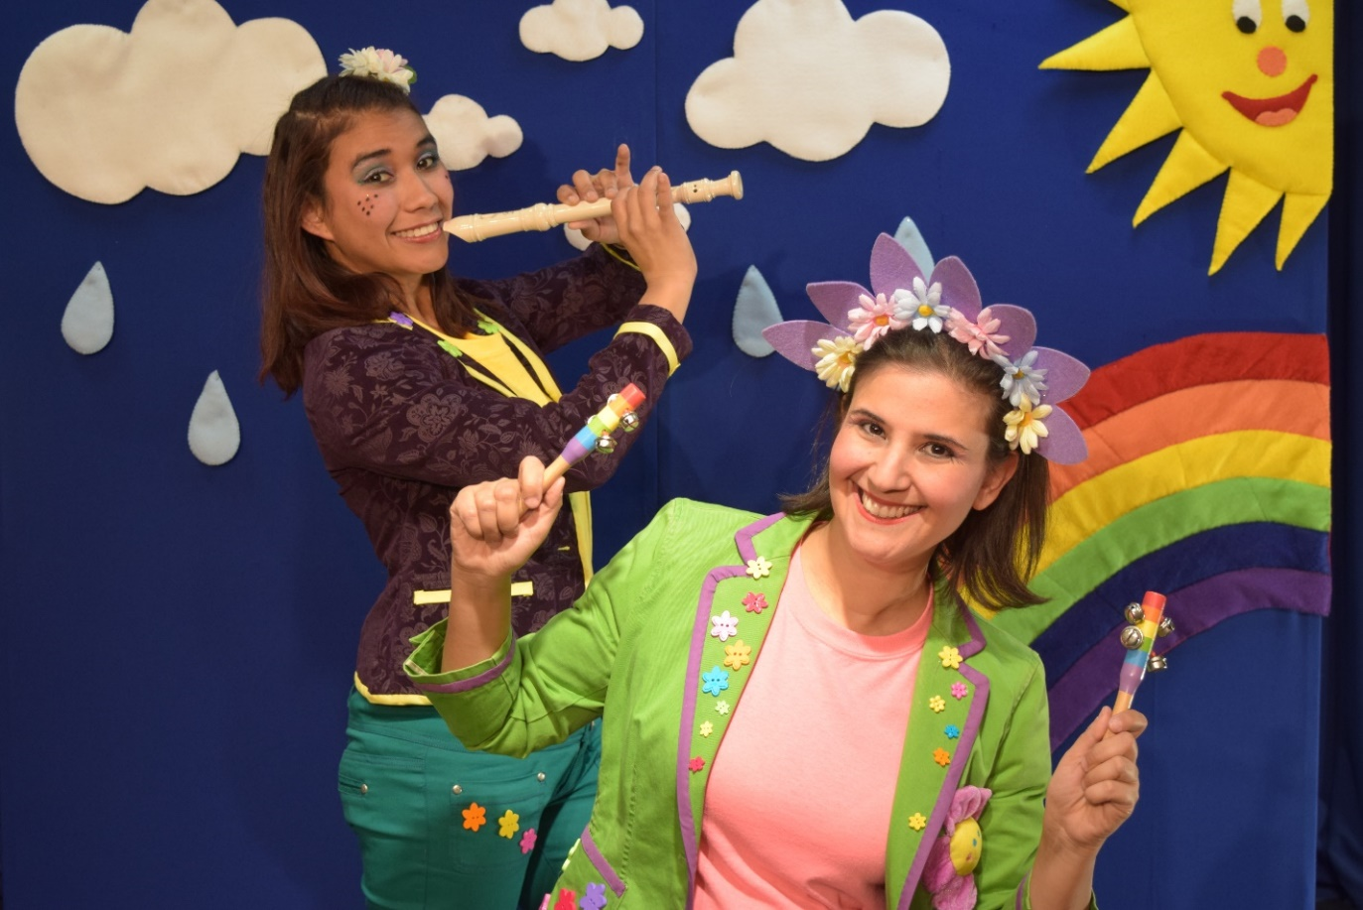
Summary of Play
¡A cantar y a aprender a mantener limpio nuestro planeta! ¡Una obra dedicada a nuestros más jóvenes amigos! Let’s sing while we learn how to keep our planet clean! A bilingual play dedicated specially to our young friends!
Clarita despierta a Lucecita, quien tuvo un mal sueño; ella soñó que Doña Basurita quería ensuciar el Planeta Tierra. Las actrices comienzan a recrear el sueño y luego con la ayuda de Clarita y la audiencia, Doña Basurita aprende que hay que cuidar nuestro planeta Tierra. Al final, Doña Basurita aprende la lección se convierte en Doña Limpiecita.
Clarita wakes up Lucecita who was having a bad dream about Miss Trash dirtying the planet. The actresses begin to recreate the dream but, with the help of Clarita and the audience members, Miss Trash learns that we need to take care of our planet Earth by keeping it clean. Miss Trash eventually becomes Miss Clean!

VOCABULARIO/VOCABULARY
Arcoíris…….Rainbow
Magia….....Magic
Árboles…..Trees
Flores…….Flowers
Frutos……Fruits
Aves……..Birds
Mariposas…….Butterflies
Ensucien…….To make dirty
Casas……Houses
Calles…..Streets
Escuelas…..Schools
Papeleras…..Recycling bins
Cestos de basura…..Trash cans
Dientes….Teeth
Cáries…..Cavities
Tranquila….calm
Defender…..to defend
Peligro…..danger
Atraviesan…..to go through
Colores…..colors
Rojo….red
Naranja….orange
Amarillo…..yellow
Verde….green
Azul claro….light blue
Azul oscuro…..dark blue
Violeta…..purple
Enemigos….enemies
Doña Basurita…..Miss Trash
Doña Limpiecita….Miss Clean
Bonita…..Pretty
Limpieza…..Cleanliness
Defensoras…..Defenders
Limpia….Clean
Feliz….Happy

Frases/Phrases
Ella se aparece en sueños…..She appears in dreams
Lucecita tenia razón! ...Lucecita was right!
Porque mientras caminaba por las calles de ésta ciudad….Because while I was walking through the streets of this city.
Ví a dos señores comer y luego arrojar el resto de su basura….I saw two men eat and then throw the rest of their trash.
Luego ví a una niña destruir las flores de un jardín…..Then I saw a girl destroy the flowers of a garden.
¿Están de acuerdo conmigo queridos míos? Do you agree with me, my friends?
Rayar las paredes de esta escuela…..Mark the walls of this school.
Ensuciar los pisos…..Dirty the floors.
Romper los útiles de sus compañeritos….Break your classmates’ utencils.
Cuando toca a un niño o a una niña, los transforma en sus ayudantes….When she touches a boy or a girl, she transforms them into her helpers.
Yo mientras, enseñaré a los niños las canción del arcoíris…..In the meantime, I will teach the kids the rainbow song.
Un arcoíris se formó…..A rainbow appeared
Porque llovió y el sol salió…..Because it rained and the sun came out
Ahora debo desaparecer a mis principales enemigos…..Now I must disappear my main enemies.
Tienen el poder de transformar lo feo en bello y lo malo en bueno…..They have the power of transforming the ugly into the beautiful and the bad into the good.
Pero qué sorpresa se va a llevar cuando no encuentre sus instrumentos musicales….She will be surprised when she won’t see her musical instruments.
Doña Basurita no resiste escuchar el nombre de los colores porque ella solo ama el grís…..Miss Trash can’t stand hearing the names of the colors because she only loves the color grey.
Gracias a ellos y a la magia del arcoíris! Thanks to them and the magic of the rainbow!
La música unida a la alegría del color puede vencer cualquier maldad! Music, along with the happiness of color can defeat any evil!
Atentos a cuidar sus casas para que sea un hogar cálido y dulce…..Take care of your houses so they are cozy and sweet.
Atentos a tener una ciudad limpia y cuidada….Make sure you have a clean and cared for city.
Una ciudad hace a un país…..A city makes a country.
Un país hace a un planeta….A country makes a planet.
Defensoras de una ciudad limpia y felíz…..Defenders of a clean and happy city.

Classroom Activities
Pre-K
*Draw your own rainbow using the colors red, yellow, green, blue, purple and orange.
*Draw what you think Miss Trash looks like!
1st grade
Draw a dirty school and a clean school.
Draw a dirty planet and a clean planet.
2nd grade
Write a letter to Miss Trash explaining why it’s important to have a clean planet.
3rd grade
Write a list of things you can do to keep your planet clean!
Biography of playright and director: Neher Jacqueline Briceño
Ms. Briceño was born and grew up in Venezuela. She began acting in 1973, when she joined the University Theater children’s theater group at the University of Carabobo in Venezuela. After several years, she became more interested in other parts of theater. She learned about producing, directing, working with music, playwriting and working with children. Finally, she took over the direction of the Academy of Children’s Theater for more than twelve years!
During that time, Ms. Briceño took part in more than 40 shows that included classical theater, Spanish theater and children’s theater. She won many awards for her work.
In 1997, Ms. Briceño moved to Miami, Florida. She started the Miami Children’s Theatre. The Miami Children’s Theatre was invited to bring a show to Teatro de la Luna’s International Festival of Hispanic Theater, where she first met the people from Teatro de la Luna. Since then, she has come back to create many shows for Teatro de la Luna’s Experience Theater Program. Ms. Briceño also wrote and directed Aprendiendo Juntos (Drop In, Not Out), Siempre Amigos (Buddies not bullies), Sanos y Contentos (Happy and Healthy), Gotas de Agua (Drops of Water), El Gato y la Gaviota (The Cat and the Seagull), ABE: un sueño cumplido (ABE: a Dream Fulfilled), Hansel y Gretel (Hansel and Gretel), La Bella Durmiente (The Sleeping Beauty) and Las Aventuras de Pinocho (The Adventures of Pinocchio).
Ms. Briceño also won an important international award in Spain for an adult play she wrote.
Jacqueline Briceño still lives in Miami with her son, who is also bilingual.

